：；HSK
资助内容及标准
Confucius Institute Scholarship Coverage and Criteria
一学年硏修生
One-Academic-Year Study
汉语国际教育专业硕士
MTCSOL
汉语国际教育本科
BTCSOL
奖学金类别 SCHOLARSHIP TYPES
一学期研修生
One-Semester Study
四周硏修生
Scholarship for Four-Week Study
奖学金线上项目
Scholarship for Online Programmes
international Chinese
2022
REASONS TO
STUDY IN
HSK
新中国最早建立的4所外语院校之一
西北地区最早开展留学生汉语教学的院校
完善的教学设施 Exellent teaching facilities
良好的学习环境 Favorable learning environment
现有博士研究生、硕士研究生、本专科生、外国留学生及各类培训学生2万人.
丰富的历史文化资源
Abundant historical and cultural resoura 繁华的现代都市商圏 Bustling modern urban business district 便利的交通条件 Convenient transportation
语言环境多样化
Diversified language environment 视野国际化
师资力量雄厚，成效明显
中国西北地区唯一认证的HSK (笔试及机考)和HSKK考点单位.
The only certified HSK (written examination and computer-based examination) and HSKKtest center in Northwest China
历史悠久，教学经验丰富 Rich teaching experience
研修旅游、语言实践 Academic study, traveling and language learning
文化体验、各类比赛 Cultural immersion and exchanges
一学期研修生  One-Semester Study | ▲注册费▲学费▲校内住宿费  ▲保险费  ▲生活补助：一学年和一学期研修生、 榊生2500元/月;硕士3000元/月  - Exempt from: Registration Fee, Tuition, Accommodation, Insurance Fee  - Living allowance:  ¥ 2500/month ( One-Semester Study, One-Academic- Year Study, Undergraduate ) ; ¥ 3000/month (Postgraduate)
一学年研修生
One-Academic-Year Study
汉语国际教育专业硕士 MTCSOL
汉语国际教育专业本科生
BTCSOL
奖学金线上项目  Scholarship for Online Programmes | ▲学费  ▲Tuition Fees

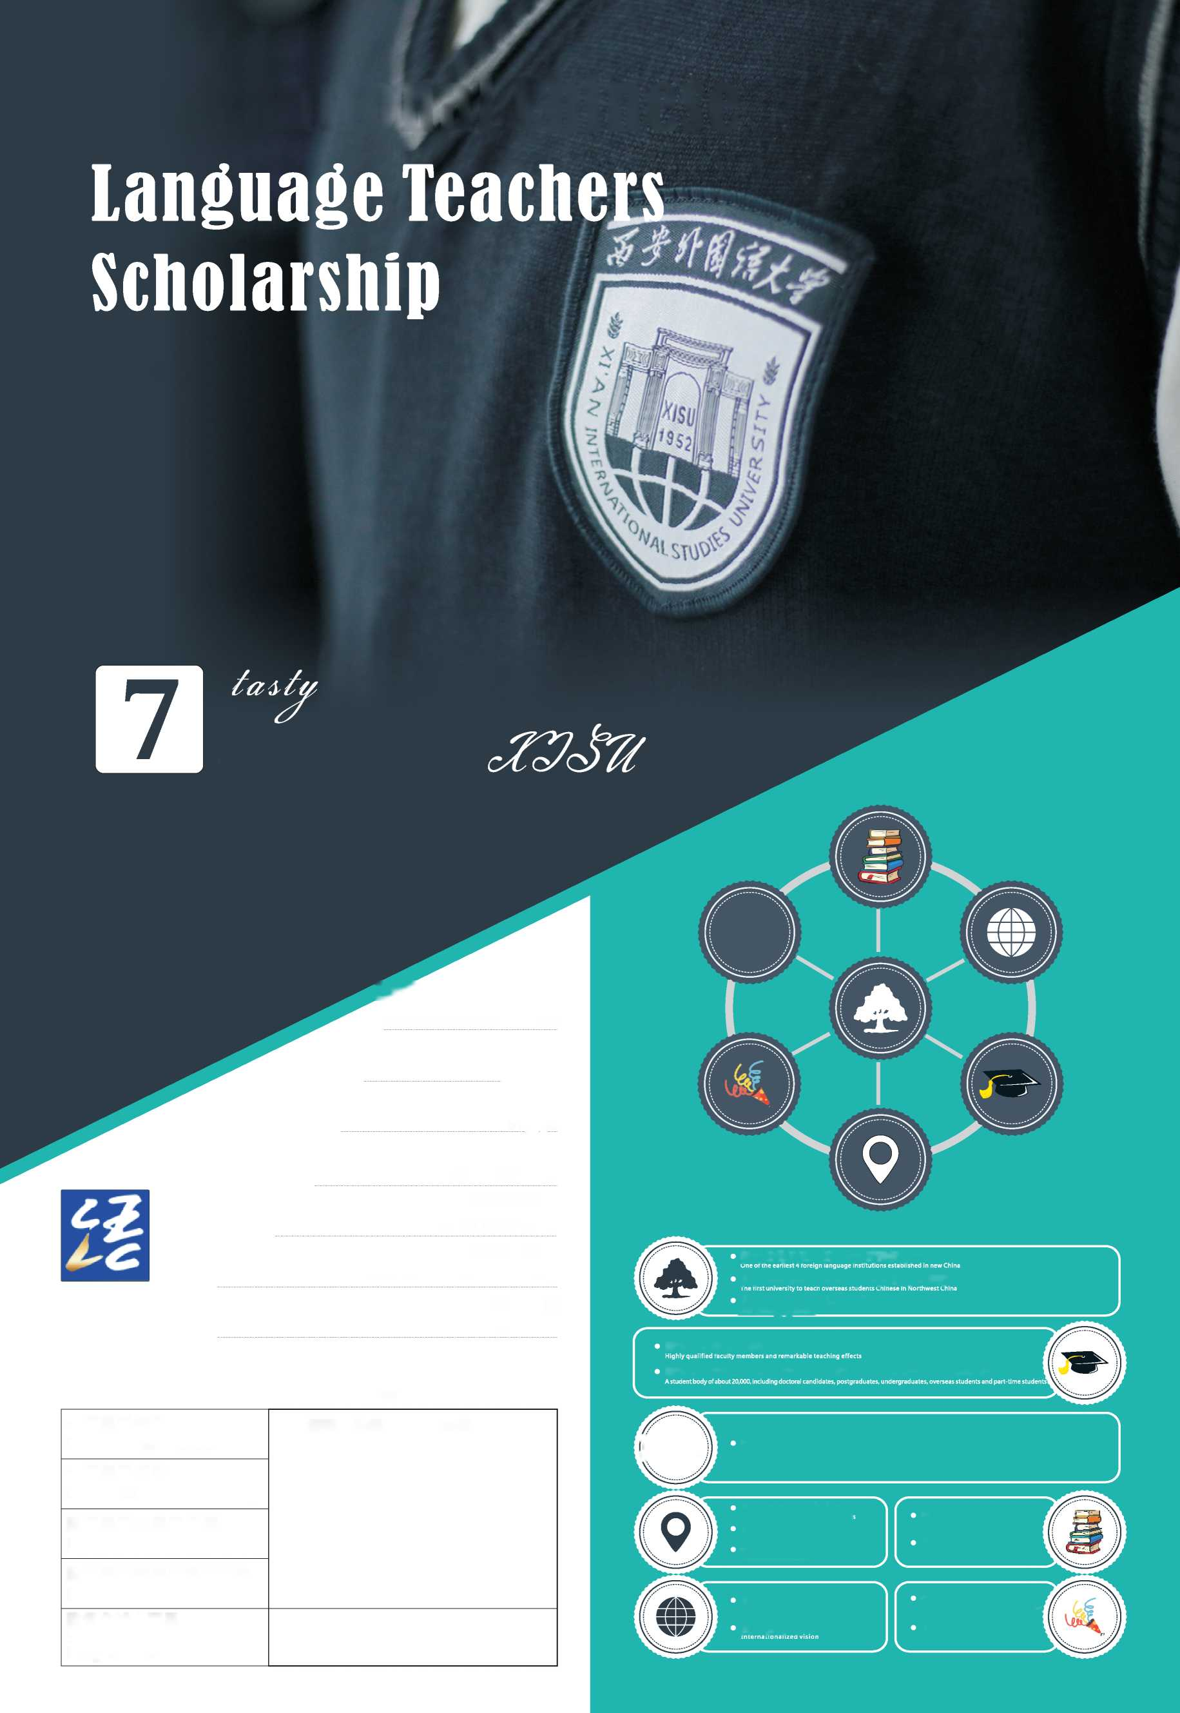

为满足国际社会对日益增长的中文教育类人才的需求，促进世界各国中文教育的 发展，助力国际中文教育人才的成长，教育部中外语言交流合作中心(以下简称中 心)设立国际中文教师奖学金(以下简称奖学金)，聚焦培养合格的海外中文教师。 孔子学院、独立设置的孔子课堂，部分汉语考试考点，外国相关教育机构、高校中文 师范专业/中文院系、国外有关中文教学行业组织、中国驻外使(领)馆等(以下简称 推荐机构)可推荐优秀学生和在职中文教师到中国大学学习和进修汉语国际教育及相 关专业。
西安外国语大学位于中国最古老的首都、古丝绸之路的起点一一西安，是中国最 早创办的四所高等外语院校之一，是中国西北地区最早从事留学生汉语教学的高等院 校，也是中国西北部首家认证的HSK (汉语水平考试)、HSKK (汉语水平口语考试) 考点。
For the purpose of satisfying the growing demand of the international community for Chinese language teachers and facilitating Chinese language education in other countries, the Center For Language Education And Cooperation (CLEC) will continue with the International Chinese Language Teachers Scholarship. Confucius Institutes, independently operated Confucius Classrooms, certain HSK test centers, Chinese language (education) departments of foreign universities, professional associations for Chinese language instruction of other countries, Chinese embassies (consulates) abroad (collectively ^{H}recommending institutions" ) may recommend outstanding students and currently-employed Chinese language teachers to study International Chinese Language Education or related majors in Chinese universities and colleges .
Xi'an International Studies University(XISU) is located in Xi'an, the oldest capital of China and the starting point of the ancient Silk Road. It is one of the first four foreign language universities established in China. As the first university to teach foreign students Chinese in Northwest China, XISU also the first certified test center for HSK (Hanyu Shuiping Kaoshi) and HSKK (Hanyu Shuiping Kouyu Kaoshi) in Northwest China.
•我校课程设置分为汉语言进修和汉语国际教育及汉语言文学的专业课， 实行学分制。
•我校1995年开贻招收外国留学生的汉语言本科专业，汉语国际教育 硕士专业的留学生培养人数长期位列西北地区第一。
•西安外国语大学有能力为留学生提供最优质的教育教学条件。
The curriculum of XISU is divided into Chinese Language Learning, TCSOL and Chinese Language and Literature and the credit system is implemented. In 1995, XISU started to recruit foreign students of Bachelor⁷ s Degree in TCSOL and the number of foreign students of Master' s Degree in TCSOL cultivated by XISU has long been ranked first in Northwest China. Xi'an International Studies University has the ability to provide foreign students with the best education and teaching conditions.

欢迎海内外学子申请报考西安外国语大学!
Welcome students from both home and abroad to apply for XISU!
资助对象
ELIGIBILITY
非中国籍人士。
对华友好，无违法犯罪记录，遵守中国政府的法律、法规和学校的规章制度。
•身心健康,品学兼优。
有志于从事汉语教育、教学及汉语国际推广相关工作。
年龄为16-35周岁（统一以2022年9月1日计）。在职汉语教师放宽至45周岁， 本科奖学金申请者一般不超过2 5周岁。
All applicants shall be
Non-Chinese citizens
Should be friendly to China, have no criminal record, and abide by the laws and regulations of the Chinese government and the rules and regulations of the school.
In good Physical and mental condition, well performed both academically and behaviorally Aspired to take future careers on the teaching or international promotion of Chinese language Between the ages of 16-35 on September 1st, 2022. Applicants currently worked as Chinese language teachers shall not exceed the age limit of 45, while undergraduate students shall not exceed the age limit of 25
奖学金类别及申请条件
SCHOLARSHIP TYPES AND QUALIFICATIONS

中文师资类项目

A. Chinese Language Teacher Programme
汉语国际教育专业硕士 （16-35周岁）
Scholarship for Master* s Degree in Teaching Chinese to Speakers of Other Languages （MTCSOL）
2022年9月入学，资助期限为2年
•具有大学本科学历
•汉语考试成绩达到HSK （五级）210分、HSKK （中级）60分 提供毕业后拟任教机构工作协议或相关证明者优先
Commences September 2022 and provides scholarship for maximum two academic years. Applicants shall be Bachelor degree holders and between the age of 16-35 and have a minimum score of 210 in HSK Test (Level 5) as well as 60 in HSKK test (Intermediate Level). Applicants who are able to provide notarized document of the employment agreement or related proofs upon completing study in China are preferred.
[ | 2 | 汉语国际教育本科(16-25周岁)  Scholarship for Bachelor* s Degree in Teaching Chinese to Speakers of Other Languages (BTCSOL)  ♦

2022年9月入学，资助期限为4年
•具有高中学历
•汉语考试成绩达到HSK （四级）210分、HSKK （中级）60分
Commences September 2022 and provides scholarship for maximum four academic years. Applicants must have graduated with a high school diploma and between the age of 16-25 and have a minimum score of 210 in HSKTest (Level 4) as well as 60 in HSKK test (Intermediate Level).
—学年研修生(16-35周岁)Scholarship for One-Academic-Year Study
2022年9月入学，资助期限为11个月。不录取享受过同类奖学金的申请者。
Commences September 2022 and provides scholarship for maximum 11 months.
Applicants shall be between the age of 16-35.
International students who have benefited from similar scholarships are not eligible.
汉语国际教育
TCSOL
汉语考试成绩达到HSK (三级)270分，具有HSKK成绩
Applicants shall have a minimum score of 270 in HSK test (Level 3), while HSKK test score required.
汉语言文学
Chinese Language and Literature
汉语考试成绩达到HSK (四级)180分、HSKK (中级)60分
Applicants shall have a minimum score of 180 in HSK test (Level 4) and 60 in HSKK test (intermediate level).
汉语研修
Chinese Language Study
汉语考试成绩达到HSK (三级)210分，提供HSKK成绩者优先。 Applicants shall have a minimum score of 210 in HSK test (Level 3). Priority will be given to applicants who provide an HSKK test score.
—学期硏修生（16-35周岁）
Scholarship for One-Semester Study
2023年9月、2023年3月入学，资助期限为5个月
不录取护照上有XI、X2签证者
Commences either in September 2022 or March 2022 and provides scholarship of maximum 5 months.
Applicants withholding visas XI or X2 are not eligible.
Applicants shall be between the age of 16-35.
汉语国际教育
TCSOL
汉语考试成绩达到HSK （三级）180分，具有HSKK成绩 Applicants shall have a minimum score of 180 in HSK test （Level 3）, while HSKK test score required.
汉语言文学
Chinese Language and Literature
汉语考试成绩达到HSK （三级）180分，具有HSKK成绩 Applicants shall have a minimum score of 180 in HSK test （Level 3）, while HSKK test score required.
四周研修生（16-35周岁）
Scholarship for Four-Week Study
2022年7月或12月入学，资助期限为4周
不录取护照上有XI、X2签证者。
Commences either on July or December of 2022 and provides a four-week scholarship.
Applicants withholding visas XI or X2 are not eligible.
Applicants shall be between the age of 16-35.
汉语研修
Chinese Language Study
具有HSK成绩。可由推荐机构组团进行报名，并事先联系接收院校确定在华学习计 划，提前报中心审批/每团10-15人。
An HSK test score is required. The program may be organized and applied for by a recommending institution with 10-15 participants per group. Prior to the trip, a detailed study plan shall be made in consultation with host institutions and such plan shall be submitted to CLEC for approval.

奖学金线上项目

B、Scholarship for Online Programmes
—学年汉语研修线上项目（16-35周岁）
Online Programme for One-Academic-Year
Chinese Language Study
•每年9月或3月入学。
- 一般汉语水平考试成绩需达到HSK （三级）180分，提供HSKK成绩者优先。
- Commences in September or March each year.
- A general Chinese proficiency test score of 180 in HSK （Level 3） is required, and HSKK scores are preferred.
—学期汉语研修线上项目（16-35周岁）
Online Programme for One-Semester
Chinese Language Study
•每年9月或3月入学。
- 一般需具有汉语水平考试（HSK）成绩（对级别和成绩不作具体要求）。
- Commences in September or March each year.
- Generally, applicants must have an HSK score
（no specific requirements for level or score）.
.,专项线上硏修项目（16-35周岁）
U For Special Online Study Programme
•具体申请条件和申请办法，请咨询相关接收院校。
• Please consult the relevant host institutions for specific application requirements and methods of application.
申请流程
APPLICATION PROCEDURES
2022年3月1日起，申请者可登录国际中文教师奖学金报名网站（cis.chinese.cn ）,注册后按照要 求在线上传申请材料，报考院校请选择西安外国语大学，并确定申请专业。提交后，请及时关注申请进 程、审核意见与奖学金评审结果；奖学金被授予者请在线打印获奖证书，并与我校尽快确认办理来华留 学手续，请按照规定的时间入学报到。联系邮箱：admission@xisu.edu.cn
Online registration will be available from March 1, 2022 on the International Chinese Language Teachers Scholarship application website (cis.chinese.cn). After registering, applicants should upload the application materials in accordance with the requirements. Applicants should choose XISU from host institutions and apply for a major. After submitting, please pay attention to the application process, feedback of review and admission results. Scholarship holders are requested to print out CIS certificate online, scholarship holders also need to confirm with XISU to go through the procedures of studying in China and register at XISU at the designated date and time as per the letter of admission. E-mail: admission@xisu.edu.cn
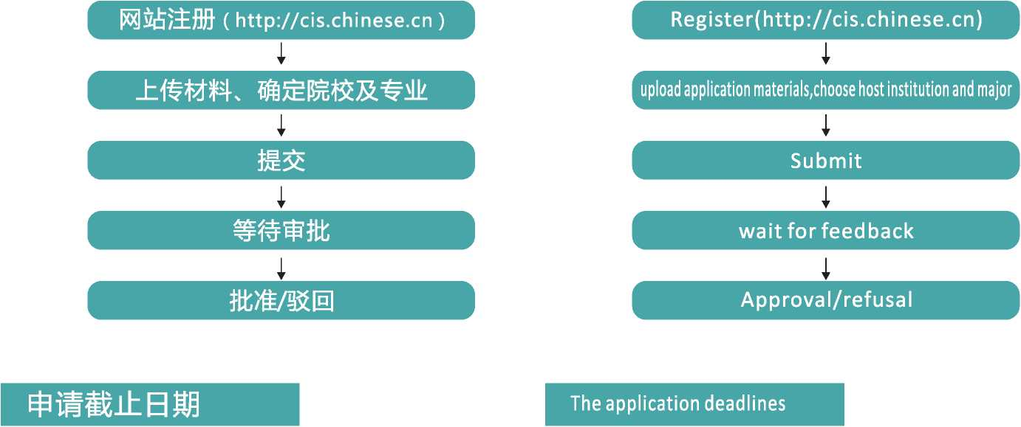
•4月15日（7月入学）
- 5月15日（9月入学）
- 9月15日 （12月入学）
- 11月15日（2022年3月入学）
•中心委托专家组集中评审：根据HSK、 HSKK考分和级别，兼顾国别等因素 择优资助，于入学前约3个月完成奖 学金评审工作，公布评审结果。
- April 15th (for those commencing in July).
- May 15th (for those commencing in September).
- September 15th (for those commencing in December).
- November 15th (for those commencing in March 2022).
- CLEC will entrust an expert panel to review the applications.
Decisions will be made based on HSKand HSKK scores and levels, and in consideration of country distribution as well as other factors. The results will be published about three months before school starts.

关于在职中文教师和汉语桥获奖者
POLICIES REGARDINGCURRENTLYEMPLOYEDCHINESELANGUAGE TEACHERSAND CHINESE BRIDGE AWARD RECIPIENTS
在职中文教师
Currently employed Chinese language teachers
•在职中文教师申请各类奖学金，可提供就职机构出具的在职证明和推荐信，免提交汉语水平考试(HSK )证书。
• Currently employed Chinese language teachers applying for the scholarships can be exempted from submitting Chinese Language Proficiency Test (HSK) certificates if they can provide proof of employment and a letter of recommendation from the institution where they work.
汉语桥获奖者
Chinese Bridge Award Recipients
•在各类汉语桥比赛中获得2022年度”国际中文教师奖学金证书"者，登录国际中文教师奖学金网站，凭 奖学金证书向我校提交申请材料。
• Chinese Bridge winners who have been awarded the 2022 International Chinese Language Teachers Scholarship Certificate shall log onto the International Chinese Language Teachers Scholarship website and submit documents to XISU upon presentation of their scholarship certificates.
如有问题,请咨询 chinesebridge@chinese.cn。
For inquiry, please contact chinesebridge@chinese.cn.
推荐机枸和投收院校
ADMISSION AND CONSULTATION SERVICES
推荐机构和接收院校依据本办法履行属地责任，提供咨询、推荐、招生等服务。
Recommending institutions and host institutions are responsible for issuing local enrollment guide and provide consulting, recommending and registering services in accordance with this procedure.
西安外国语大学为HSK考点，可作为国际中文教师奖学金推荐机构,详情可咨询考点办公室。
Xi'an International Studies University is the HSK test center. It can be functioned as a International Chinese Language Teachers Scholarship recommendation agency. For details, please contact the test center office.

联系人：张锋
电子邮箱：hxy@xisu.edu.cn
联系电话:+86-29-85309600
Liaison person: Zhang Feng
E-mail: hxy@xisu.edu.cn
Tel: +86-29-85309600

西安外国语大学留学生招生办公室
电子信箱：admission@xisu.edu.cn
联系电话:+86-29-85309431
Email: admission@xisu.edu.cn
Fax: +86-29-85309431
语合中心考试与奖学金处
Division of Test and Scholarships
其它

OTHERS
•相关专业的培养方案与教学课程，可咨询我校
•申请者须了解我校的具体招生条件及报名截止时间，按照相关规定提交申请材料
•学历生须参加年度评审，详见《国际中文教师奖学金年度评审办法》
•新冠肺炎疫情期间，相关入学等事宜，请及时联系接收院校。
•入学体检不合格、中途退学、及未经许可不按时报到、休学等情况，取消奖学金资格。
- For major training plans and courses, please contact designated host institutions
- Applicants shall be familiar with the specific criteria and closing dates for registration, and follow specific procedures to submit necessary documents
- Degree students are subject to the annual assessment according to the Annual Appraisal
Procedures of International Chinese Language Teachers Scholarship.
- For enrollment and other matters during the Covid-19 epidemic, please contact the host institutions.
- Students who fail to pass the pre-enrollment medical examination, withdraw from school midway, or fail to report to school or suspend their studies without permission will be disqualified for scholarship.
联系方式

CONTACTS
International Student Admission Office of XISU

电子信箱：scholarships@chinese.cn 电话:+86-10-58595727
+ 86-10-58595932 (亚洲、非洲)
+ 86-10-58595999 (美国、加拿大)
+ 86-10-58595744 (拉美、大洋洲)
+ 86-10-58595875 (欧洲)
Email: scholarships@chinese.cn
Tel: +86-10-58595727
+ 86-10-58595932 (Asia, Africa)
+ 86-10-58595999 (US, Canada)
+ 86-10-58595744 (Latin America, Oceania)
+ 86-10-58595875 (Europe)
国际中文教师奖学金资助内舂及标准
INTERNATIONAL CHINESE LANGUAGE TEACHERS SCHOLARSHIP COVERAGE AND CRITERIA
奖学金资助内容
Scholarship Coverage
•学费、住宿费、生活费(四周研修生除外)和综合医疗保险费。
The Confucius Institute Scholarship provides full coverage on tuition fee, accommodation fee, living allowance (four-week study students are excluded) and comprehensive medical insurance expenses.
学费
Tuition fee
•学费由接收院校统筹用于奖学金生的培养与管理，开展文化活动，组织参加汉语考试。 奖学金线上项目仅资助学费。
Tuition fee is under the overall planning and utilization of host institutions to provide teaching and management of scholarship students organizing cultural and social activities, as well as organizing Chinese language proficiency tests. The scholarship online programmes only support tuition fees.
住宿费
Accommodation fee
•住宿费由接收院校统筹使用，为学生提供免费宿舍，一般为双人间；经奖学金生申请、 接收院校批准，选择校夕M主宿者，由学校按月或季度发放住宿费，标准为70吃人民币/月。
Accommodation fee is under the overall planning and utilization of host institutions to provide students with in-campus apartments (usually double rooms). Students may also live off-campus upon application and getting permission from the host institutions. Students who live off-campus are entitled to accommodation allowance of 700 CNY per person/month paid on a monthly/quarterly basis from the host institutions.
生活费
Living allowance
•生活费由接收院校按月发放
•本科生、一学年和一学期研修生标准为2500元人民币/月
•汉语国际教育专业硕士生为3000元人民币/月
- Living allowance is granted by host institutions on a monthly basis.
- The monthly allowance for undergraduates, one-academic-year study students and one-semester students is 2,500 CNY per person.
- For MTCSOL student, the monthly allowance is 3,000 CNY per person.
※奖学金生按接收院校录取通知书规定的时间入学报到，否则取消奖学金资格。 当月15日（含15日）前到校注册者，当月发放全额生活费；15日以后注册者， | 当月发放半月生活费。 I
※奖学金生在学期间（不含寒暑假）因个人原因离开中国时间超过15天者，停发 ' 离华期间生活费。 I
※奖学金生因个人原因休学、退学或受接收院校纪律处分者，停发自休学、退学
■ 或接到处分通知之日起的生活费。 |
I※毕（结）业生的生活费发放至学校确定的毕（结）业日期后的半个月。 I
※所有学历生需参加年度评审，符合条件者方可继续享受下一年度奖学金。
Students are required to complete enrollment procedures for every semester within stipulated period; otherwise, their scholarship may be cancelled. Students who are enrolled before the 15th （or on the 15th） of the month are entitled to the full allowance of that month while those enrolled after the 15th of that month are only entitled to half of the amount.
During the study period, for any student who is absent from China due to personal reasons for more than 15 days （excluding winter and summer holidays）, the allowance during absence will be suspended.
For students who suspend study or drop out of school for personal reasons, or who are given disciplinary punishment by the host institutions, allowance will be terminated on the date of such suspension, dropping out or when the decision of such punishment is announced.
The living allowance for the month of graduation will be granted half a month after the date of graduation or expiration day of the study confirmed by host institutions.
All undergraduate & graduate students are required to participate in the annual assessments, and those who meet the criteria can continue to enjoy the scholarship for the next year.
综合医疗保险费
Comprehensive medical insurance
•综合医疗保险费参照中国教育部来华留学有关规定执行，由接收院校统一购买
•四周研修生标准为160元人民币/人
- 一学期硏修生为400元人民币/人
- 一学年以上标准为800元人民币/年/人
Comprehensive medical insurance is purchased by the host institutions in accordance with relevant regulations of studying in China stipulated by the Ministry of Education of China. Insurance fee per person is 160 CNY for four-week study students, 400 CNY for one-semester students, and 800 CNY peryear for students engaged in program longer than one academic year.
国际中文教师奖学金申请材料清单

APPLICATION DOCUMENTS FOR INTERNATIONAL CHINESE LANGUAGE TEACHERS SCHOLARSHIP
所有申请者均需提父的材料
For all applicants
•护照照片页扫描件
- HSK、HSKK成绩报告(有效期两年)扫描件
•推荐机构负责人的推荐信
- A Scanned copy of passport photo page
- A scanned copy of score reports of the HSK and HSKK tests (within the two-year validity).
- A Recommendation letter by the head of the recommending institutions
本科生与硕士生另须提交的材料
For degree scholarship program applicants
•经过公证的最高学历证明(毕业预期证明)
•在校学习成绩单
•汉语国际教育专业硕士须提供两名副教授以上职称导师的推荐信
•提供毕业后拟任教机构工作协议者优先资助
- A certification of the highest education diploma (or proof of expected graduation) and an official transcript.
- Applicants of the Scholarship for MTCSOL Students are required to provide 2 reference letters from professors or associate professors. Those who can provide a notarized employment agreement with teaching institutions are preferred.
在职汉语教师另须提交的材料
Applicants currently worked as Chinese language teachers
•就职机构出具的在职证明和推荐信
• Applicants currently worked as Chinese language teachers shall provide the proof of employment as well as a reference letter by the employing institution
未满18周岁申请者另须提交的材料
Applicants under the age of 18
•在华监护人署名的委托证明文件
• Applicants under the age of 18 shall provide certified documents of designation signed by
their entrusted legal guardians in China.
其他须向我校提交材料
Other materials
•面试时我校将单独通知
• Other materials that need to be submitted to XISLJ will be notified during the interview.
❷申请者在申请陈述中，须说明申请人汉语学习背景、来华学习计划及目标。
The applicants should state in the application statement their Chinese learning background , their study plan and study objectives in China.
声明 Disclaimer
- 申请材料不完整或不符合招生条件的，概不受理，
- 申请材料弄虚作假，或非本人填写提交的，一经查实，申请资格将被取消。
- 获奖者因故不能报到，应在报到日前15天书面告知接收院校并注明原因。无故未报到者，取消奖学金资格。
- 入学体检不合格，或中途退学、休学者，奖学金资格将被取消。
- If the application materials are incomplete or incompatible with the enrolment conditions, they will not be accepted.
- If the application materials are fraudulent or are not submitted by the applicant, the application qualification will be cancelled upon verification.
- Scholarship holders that cannot report for any reason should inform the host institution in 15 days before the reporting date and indicate the reasons. If they fail to report for no reason, scholarship holders will be disqualified from the scholarship.
- For students who have unqualified physical examination, drop out of school or leave school, the scholarship will be cancelled.

